Krishnaprasad V

1BM18CS047

**28/09/2020**

**CN Lab 2**

**Procedure:**

1. Two generic computers are placed alongside a router. They are connected with

copper cross over wires as the devices are on the same level.

2. IP addresses (fast ethernet) and default gateway addresses are configured

specifically, for each computer.

3. The router's terminal is accessed and an interface for each connection and

With the specified gateway addresses the no shut command is used to establish a

connection.

4. Using the terminals on the computers, we can ping the other computers using

their IP Address.

**Observation:**

After configuring the devices, a connection is established from the router's

Side using the command line interface. The show ip route command shows that the

computers are connected. Opening up the terminal on the computer, we can

ping another connected computer's IP address to see whether there is a

response from the sent packet. The initial attempt will be a time out but on

future attempts packets would be successfully retrieved since the computer will

be found on the network.

**Outcome:**

In today’s lab, I understood how hubs and switches work along with their differences, and in which setups and environments they are better/worse in. I also understood the working of routers, its configuration and its communication with end network devices and the use of pinging to test connections in a network and make sure all devices are connected properly and can communicate properly.

**Screenshots:**

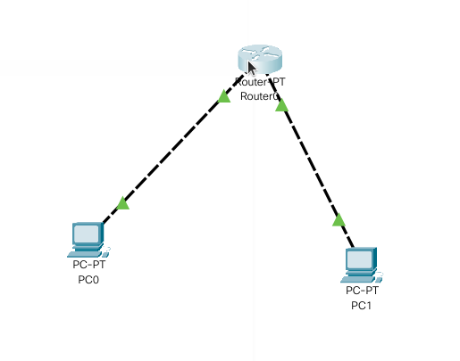

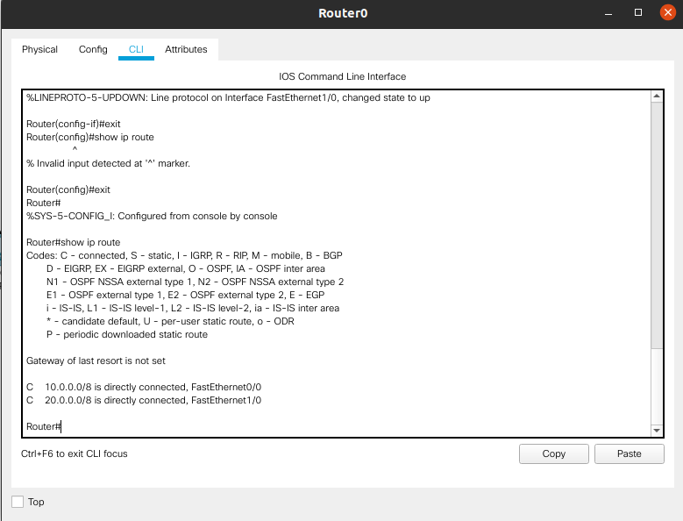

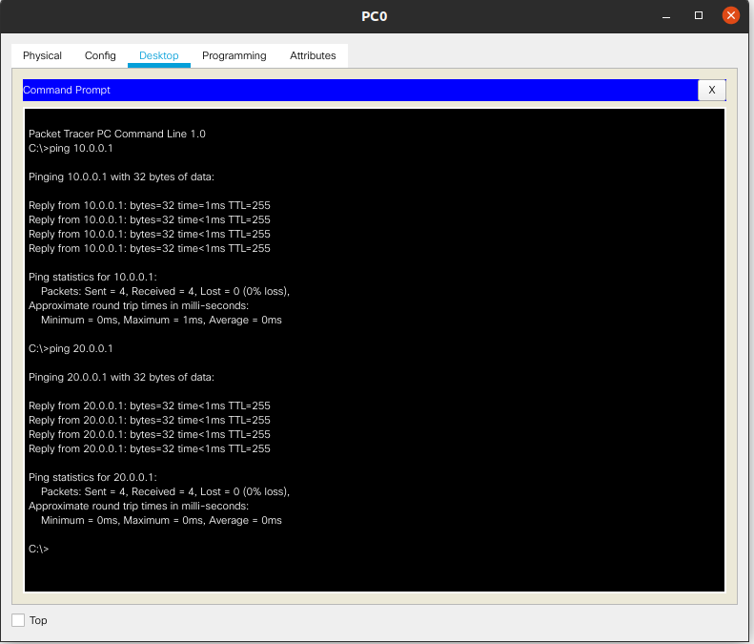**HUB & SWITCH SCREENSHOT:**

